Portfolio Tittle : Liquor Sales Trends and Inventory Efficiency Analysis
Introducetion

This project focuses on a public liquor sales and inventory movement dataset sourced from Kaggle. The analysis uses Excel as the primary tool to explore sales performance, inventory flow, and seasonal patterns. The goal is to understand how product movement translates into actual sales and to identify opportunities for improving inventory efficiency and product mix decisions.

Methodology

- Define Project Goal & Scope

- Which items show high inventory movement but low sales conversion?
- How does sales performance vary by product type and bottle size over time?
- Are there clear seasonal patterns in sales for different product categories?
- Which suppliers contribute consistently to both sales volume and inventory movement?
- How are items distributed by inventory conversion performance?

- Collect & Prepare The Data

The Warehouse Liquor and Retail Sales dataset was sourced from kaggel and analyzed on Excel. The Following steps were taken to clean and prepare for data with:
- Imported the raw CSV file into Excel using Power Query to handle the large dataset efficiently.
- Corrected data types for date and numeric fields to ensure accurate analysis.
- Selected only relevant columns related to time, product, supplier, and sales movement.
- Cleaned product descriptions to improve consistency.
- Extracted bottle size information from item descriptions using Power Query.
- Removed records with no sales or inventory movement.
After the cleaning process, the prepared dataset was loaded into Excel and used for Pivot Table analysis and dashboard creation.

- Analyze the data with Excel
- Which items show high inventory movement but low sales conversion?

This analysis compares Retail Transfers and Retail Sales to identify items with high inventory movement but low sales conversion. Several products show a clear gap between supply and demand. For example, Evan Williams Egg Nog recorded around $500 in transferred inventory but generated only about $185 in sales, indicating that a significant portion of stock remained unsold.
Items with a sales conversion ratio below 50% suggest inefficient inventory allocation. The Top 10 chart highlights products with the largest gaps between transfers and sales, pointing to potential dead stock. Reducing transfer volumes for these items would help limit inventory buildup and allow shelf space to be reallocated to higher-performing products.

- How does sales performance vary by product type and bottle size over time?

Sales performance over time shows clear differences when viewed by bottle size. Medium-sized products between 500 and 750 ml consistently act as the main revenue driver and contribute the largest share of total sales, indicating that this size range represents the core consumer preference across product types. Small-sized bottles below 500 ml display relatively stable performance throughout the period, suggesting steady personal consumption that is less affected by seasonal or external changes. Large-sized bottles above 1000 ml generate higher value per transaction but fluctuate more, reflecting their role in bulk purchasing or event-driven demand.
Temporal patterns further highlight how sales respond to specific periods and events. A seasonal peak appears in November 2019, driven by increased holiday demand, while a sharper and less typical surge occurs in March 2020, led mainly by Medium and Large bottle sizes as consumer behavior shifted toward stockpiling at the early stage of the pandemic. Meanwhile, products classified as Unknown, such as ice or non-standard items, show a gradual upward trend with a noticeable increase during mid-2020, aligning with seasonal usage. Overall, Medium sizes provide consistent revenue strength, Small sizes support stability, and Large sizes amplify sales during exception.

- Are there clear seasonal patterns in sales for different product categories?
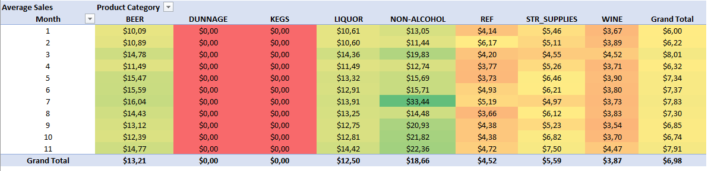
This seasonality analysis reviews recurring monthly sales patterns from 2018 to 2020 to identify peak and off-peak periods across product categories. Clear seasonal signals appear in several categories. Non-Alcohol products show the strongest intensity during July and November, indicating higher demand during summer months and holiday periods. Beer and Liquor demonstrate relatively stable performance, with sales gradually strengthening from mid-year onward. In contrast, January and February consistently record the lowest activity across most categories, confirming an industry-wide low season at the beginning of the year.
Several points from the heatmap require clarification when presenting the results.
- The Dunnage and Kegs categories consistently record zero sales, which should be explained as either non-retail items or missing data rather than true market weakness.
- Overall performance is heavily influenced by Non-Alcohol sales, making total averages sensitive to changes in this category.
- Because the analysis uses multi-year monthly averages, exceptional events such as the March 2020 pandemic surge are smoothed out and may not fully reflect short-term shocks.

- Which suppliers contribute most consistently to inventory movement over time? 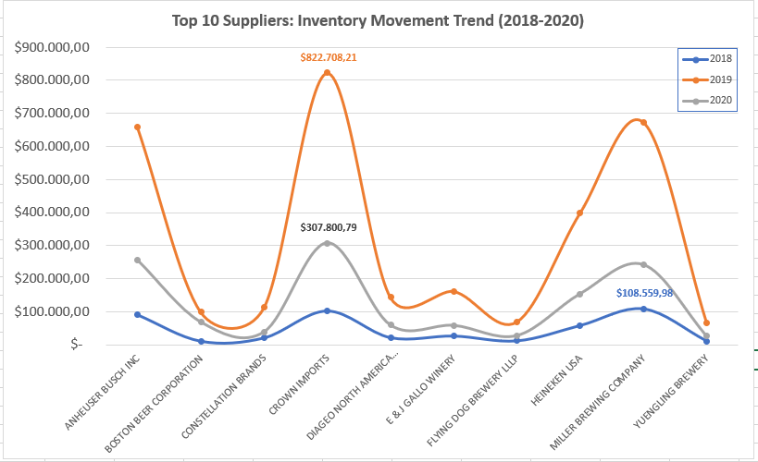
This analysis examines inventory movement and supplier performance between 2018 and 2020 to understand how effectively stock flows through the business. The data shows a recurring mismatch between inventory transfers and retail sales for several items, which signals potential dead stock and tied-up working capital. In some cases, inventory value remains high while sales conversion stays low, indicating that replenishment decisions are not always aligned with actual demand.
From a supplier perspective, inventory movement is concentrated among a limited number of key partners.
Key observations:
- Crown Imports and Miller Brewing Company show consistently high inventory activity across multiple years.
- Inventory movement peaked sharply in 2019, driven by a small group of top suppliers.
- In 2020, supplier activity became more stable, suggesting tighter inventory control or demand adjustment.

- How are items distributed by inventory conversion performance?

This analysis examines how efficiently inventory is converted into retail sales across more than 211,000 recorded items by grouping them into conversion performance categories. The results reveal a clear imbalance in the inventory portfolio. A large share of items, around 57 percent, shows no meaningful sales activity, indicating a substantial level of idle stock that absorbs capital without generating returns. Another 22 percent of items records low conversion, where inventory moves but produces limited sales value. Only a relatively small portion of the portfolio, about 12 percent, demonstrates strong conversion performance and functions as the main source of healthy sales flow.
These findings highlight where operational focus should be directed. Items with no movement represent the most immediate financial pressure and require decisive action to prevent further capital lock-in. Products with low conversion present an opportunity for improvement through better pricing or demand stimulation, while high-conversion items deserve continued support as they form the most reliable revenue base. Framing inventory performance in this way shifts attention from how much stock is held to how well that stock performs in generating sales.

Key Insight To Explore
This section consolidates the most critical findings derived from the applied analytical methodology and the five stages of analysis. The results highlight that the primary challenge does not lie in sales generation alone, but in how effectively the product portfolio and inventory are managed to support sustainable performance.
A key insight emerges from the inventory conversion analysis, where 57 percent of the 211,263 recorded SKUs fall into the No Movement category. This outcome exceeds initial expectations set during the introduction phase and points to a significant level of inactive stock within the portfolio. The scale of this finding indicates a structural inefficiency in product allocation, where a large portion of working capital is locked in items that fail to generate retail sales.
Further integration of the seasonality and supplier analyses reveals a clear efficiency gap across the supply chain. While certain products and suppliers contribute substantial inventory movement, this activity does not consistently translate into proportional retail sales. Several high-volume items remain in low conversion states, creating operational strain through storage, handling, and replenishment costs without delivering equivalent financial returns. This suggests that strong movement alone is not a reliable indicator of portfolio health.
Historical trend analysis reinforces that inventory accumulation in specific categories does not correlate with long-term profitability. The applied methodology confirms that this stagnation is not primarily driven by seasonal demand patterns, but rather by procurement strategies that are misaligned with actual market absorption. Collectively, these insights point toward the need to rebalance the portfolio by prioritizing high-conversion items that drive return on investment, while addressing low-performing and inactive SKUs through rationalization or liquidation to protect cash flow and operational efficiency.
- A large share of the product portfolio fails to generate value, with more than half of all SKUs showing no meaningful sales conversion, indicating significant capital inefficiency and inactive stock accumulation.
- Inventory activity and sales performance are misaligned, as high inventory movement does not consistently result in strong retail sales, exposing an operational gap between supply decisions and actual market demand.
- Revenue and efficiency are driven by a relatively small group of high-conversion items, suggesting that portfolio performance depends more on product quality and demand fit than on overall inventory volume.

Impact & Outcome
This analysis provides a clear view of how inventory and sales performance interact across the product portfolio, enabling more informed and targeted decision-making. By moving beyond surface-level sales trends and examining conversion efficiency, the dataset reveals where capital is effectively generating returns and where it remains tied up in inactive or low-performing stock.
The outcome of this work is a practical framework for inventory prioritization. High-conversion items can be identified and supported as core revenue drivers, while low and no-conversion products are flagged for corrective action such as rationalization, repricing, or controlled liquidation. As a result, the analysis supports improved cash flow management, reduced operational overhead, and a more demand-aligned inventory strategy that can be applied consistently across future planning cycles.

Inventory Portfolio Health Distribution
The visualization above provides empirical evidence of the inventory-sales disconnect discussed in this analysis. By categorizing 211,263 data entries, the chart highlights a significant structural imbalance where 57% of the portfolio (121,259 SKUs) is classified as "No Movement". This high concentration of dormant stock confirms that a substantial portion of the company’s capital is currently illiquid and not contributing to active retail cycles.
Conversely, the "High Conversion" segment—representing only 12% of the portfolio—stands as the primary engine for cash flow. This clear visual contrast justifies the urgent need for a demand-aligned inventory strategy, prioritizing the protection of high-velocity items while aggressively rationalizing the underperforming 79% (Low and No Movement categories combined) to reduce operational overhead.

Business Recommendations To Develop
This section translates analytical findings into clear and actionable directions that the business can realistically execute. Each point is derived directly from the observed sales patterns and operational signals in the dataset.
- Prioritize marketing efforts on high revenue contributing products. The data shows that a limited number of SKUs generate a significant share of total sales. Concentrating promotional budgets on these products can deliver faster and more measurable impact.
- Strengthen distribution through the best performing sales channels. When retail sales demonstrate more stable and consistent performance than retail transfers, inventory allocation and visibility should follow that pattern.
- Gradually reduce focus on low volume and low margin products. These items increase operational complexity while contributing minimal value to overall profitability.
- Adjust pricing strategies based on demand stability. Products with consistent sales volume present opportunities for controlled price optimization to improve margins.
- Apply historical sales trends for monthly stock planning. Data driven forecasting helps minimize overstock risk and prevents lost sales due to stockouts.

Conclusion
This analysis demonstrates how inventory performance and sales behavior are closely linked and should be evaluated together rather than in isolation. By examining conversion levels instead of relying solely on sales volume, the analysis highlights where inventory actively generates revenue and where capital remains locked in inactive stock. The findings show a clear imbalance in the portfolio, with a small portion of products driving most cash flow while a large share contributes little to no movement.
The inventory health distribution reinforces this insight by providing quantitative evidence of structural inefficiency. A dominant share of no movement and low conversion items indicates excess stock that increases holding costs and limits financial flexibility. At the same time, the high conversion segment proves that demand is concentrated and predictable when inventory aligns with customer behavior.
Overall, this work provides a practical foundation for improving inventory decision making. It supports a shift toward demand focused stock management, clearer prioritization of high impact products, and more disciplined treatment of underperforming SKUs. For beginners, this framework offers a straightforward way to connect data analysis with real business actions, making future planning more efficient, measurable, and sustainable.

Disclimer
Please note that this project was created solely to demonstrate my analytical skills using Microsoft Excel. The dataset used in this analysis is publicly available and was obtained as a static dataset. I do not own the data and have no affiliation with the data provider. All insights and conclusions are indicative only and intended for learning and portfolio demonstration purposes. They should not be used as a basis for real business or financial decision making.

